ASTR 2310 General Astronomy I – Spring 2024, Brotherton
Homework #1
Instructions: Homework write-ups should be clean and clear. Illegible or hard to understand solutions may not earn credit. In addition to the solution, the steps leading to the solution are also important to earn full credit. You may need to use information from the internet to solve some of the problems, and you should clearly state your sources if you do so. Use appropriate units and significant figures for your solutions (or uncertainties if requested). It is permissible to work in groups, but everyone must hand in their own solutions that they have written themselves.
1. What comes around goes around
The right ascension and declination of the seven stars of the Big Dipper are given below.
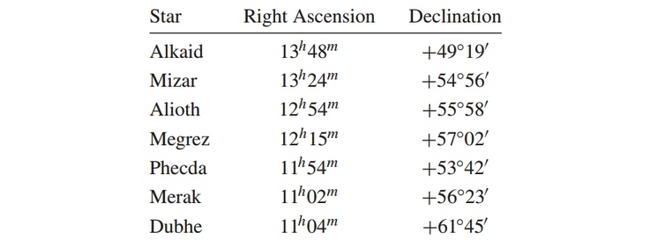
For what range of latitudes are all the stars of the Big Dipper circumpolar? What is the southernmost latitude from which all of the stars of the Big Dipper can be seen? For what range of latitudes are none of the stars of the Big Dipper ever seen above the horizon?
Solution:
Southernmost star: Alkaid, 13h 48m, +49° 19’
90° - latitude = +49° 19’, so all stars in the Big Dipper are circumpolar from latitudes 40° 41’ to 90°.
Northernmost star: Dubhe, 11h 04m, +61° 45’
61° 45’ - 90° = -28° 15’, so the southernmost latitude at which all Big Dipper stars can be seen is -28° 15’.
49° 19’ - 90° = -40° 41’, so no stars in the Big Dipper are above the horizon at latitudes from -40° 41’ to -90°.

2. The Old Man is Wrong.
In The Old Man and the Sea, Hemingway described the old man lying in his boat off the coast of Cuba, looking up at the sky just after sunset: “It was dark now as it becomes dark quickly after the Sun sets in September. He lay against the worn wood of the bow and rested all that he could. The first stars were out. He did not know the name of Rigel but he saw it and knew soon they would all be out and he would have all his distant friends.” Explain what is astronomically incorrect about this passage.

Solution:

Coordinates of Rigel, from Simbad: 05h 14m 32.3s, -08° 12’ 06”
The Sun is at a right ascension of 0h on the vernal equinox, so in September, it will have a right
ascension of around 12h. Around sunset, stars close to the meridian will have a right ascension of
around 18h. Rigel doesn’t rise until long after sunset.

3. What’s in a second?
(a) Consider two points on the Earth’s surface that are separated by 1 arcsecond as seen from the center of the (assumed to be transparent) Earth. What is the physical distance between the two points?

Solution:

Circumference of the Earth = approximately 40,075,000 m
1,296,000” in a circle
40,075,000 m/1,296,000” = 30.92 m, or around 31 m
(Could also do this with trigonometry)

(b) Consider two points on the Earth’s equator that are separated by 1 second of time. What is the physical distance between the two points?

Solution:

A second of time is 15 times larger of a fraction than an arcsecond (360/24 = 15).
15 x 30.92 m = 463.4 m.

4. Square pegs in round sky.
How many square degrees are on the complete celestial sphere? Show your math.

Solution:

C = 2πr
A = 4πr^2 = C^2/π = ((360°)^2)/π = 41,253 square degrees

5. Short answers (show any work)
a) If Betelguese is crossing the celestial meridian, what is the local sidereal time?

Solution: LST = RA on the meridian = 5h 55m 10s (from Simbad)

b) If the local sidereal time is 10:00, what is the hour angle of the star Feige 34?

Solution: LST = 10h 0m
Feige 34 coordinates (from Simbad): 10h 39m 36s
LST = HA + RA, so HA = LST - RA = -39m 36s

c) From Hawaii (lat. +20°) can you see the star α Centauri? Can you see it from Laramie?

Solution:

Alpha Centauri declination (from Simbad): -60° 50’
From Hawaii: 20° - (-61’) = 81°, yes, it is visible.
From Laramie: 41° - (-61’) = 102°, no, it is not visible.

d) From an astronomical perspective, what are the “tropics?”

Solution:

The tropics are regions between 23.5° and –23.5° latitude. These are also the most northern and
southern declinations the Sun reaches as it appears to travel along the ecliptic. Between these two
latitudes on Earth, the Sun appears directly overhead at some point in time.

