ASTR 2310 General Astronomy I – Spring 2024, Brotherton
Homework #1
Instructions: Homework write-ups should be clean and clear. Illegible or hard to understand solutions may not earn credit. In addition to the solution, the steps leading to the solution are also important to earn full credit. You may need to use information from the internet to solve some of the problems, and you should clearly state your sources if you do so. Use appropriate units and significant figures for your solutions (or uncertainties if requested). It is permissible to work in groups, but everyone must hand in their own solutions that they have written themselves.
1. What comes around goes around
The right ascension and declination of the seven stars of the Big Dipper are given below.
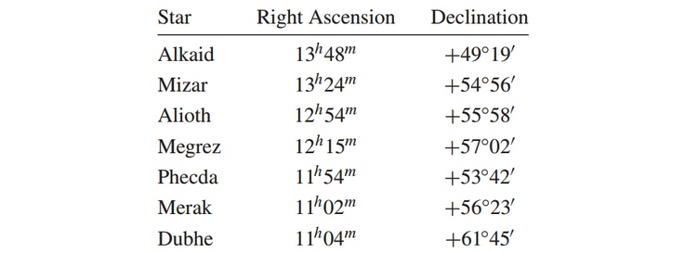
For what range of latitudes are all the stars of the Big Dipper circumpolar? What is the southernmost latitude from which all of the stars of the Big Dipper can be seen? For what range of latitudes are none of the stars of the Big Dipper ever seen above the horizon?
2. The Old Man is Wrong.
In The Old Man and the Sea, Hemingway described the old man lying in his boat off the coast of Cuba, looking up at the sky just after sunset: “It was dark now as it becomes dark quickly after the Sun sets in September. He lay against the worn wood of the bow and rested all that he could. The first stars were out. He did not know the name of Rigel but he saw it and knew soon they would all be out and he would have all his distant friends.” Explain what is astronomically incorrect about this passage.

3. What’s in a second?
(a) Consider two points on the Earth’s surface that are separated by 1 arcsecond as seen from the center of the (assumed to be transparent) Earth. What is the physical distance between the two points?
(b) Consider two points on the Earth’s equator that are separated by 1 second of time. What is the physical distance between the two points?

4. Square pegs in round sky.
How many square degrees are on the complete celestial sphere? Show your math.

5. Short answers (show any work)
a) If Betelguese is crossing the celestial meridian, what is the local sidereal time?
b) If the local sidereal time is 10:00, what is the hour angle of the star Feige 34?
c) From Hawaii (lat. +20°) can you see the star α Centauri? Can you see it from Laramie?
d) From an astronomical perspective, what are the “tropics?”

